CS Bridge Module 12 Recursions Part 2

1. Recursions - Part 2

1.1 CS Bridge: Recursions
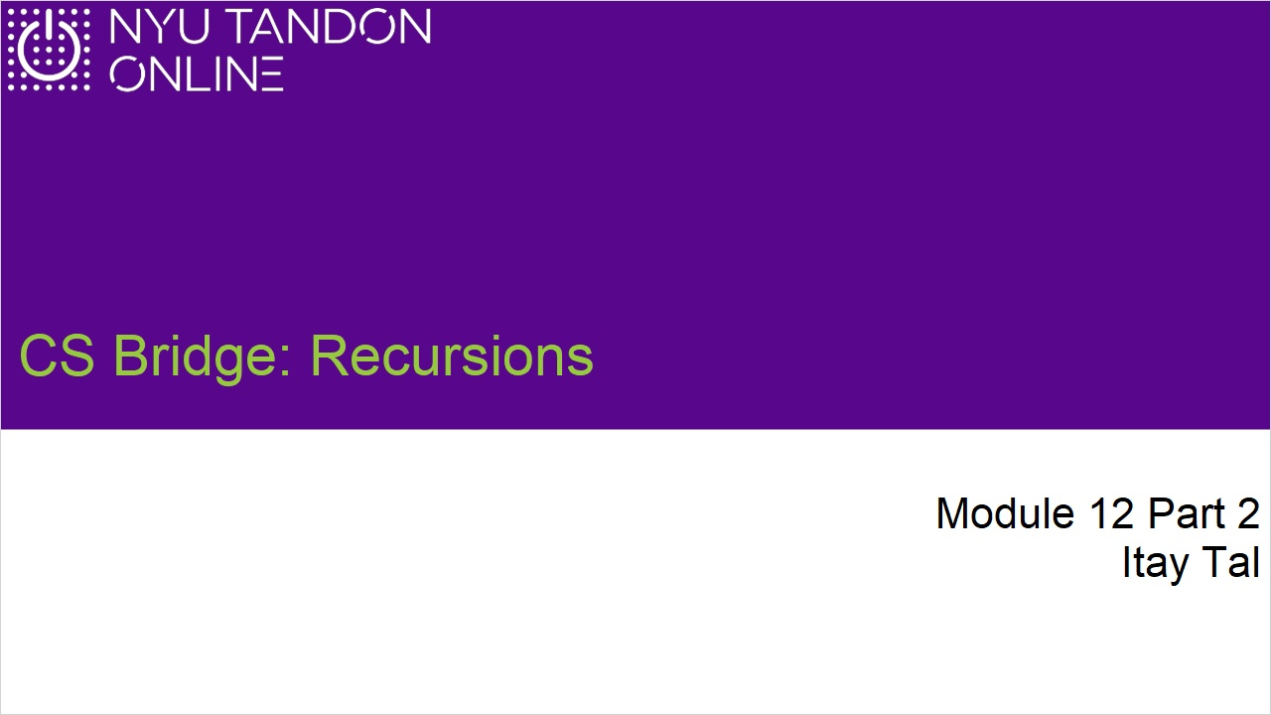
Notes:

1.2 What is Recursion?
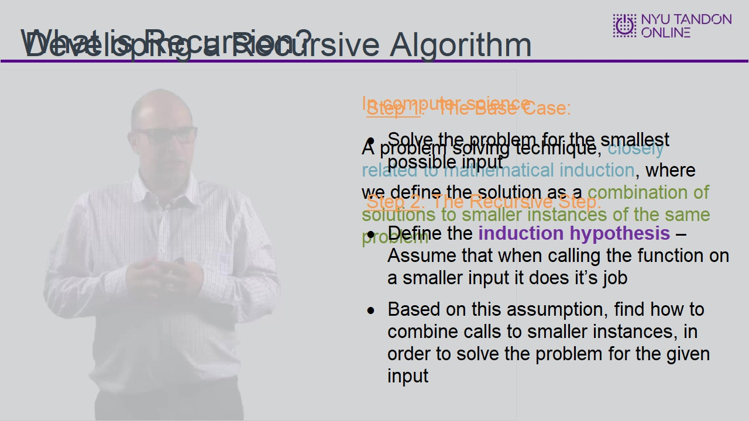
Notes:

1.3 Print Ascending Problem
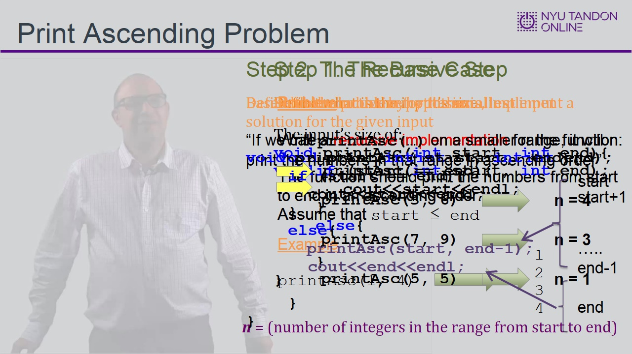

1.4 Tracing printAsc
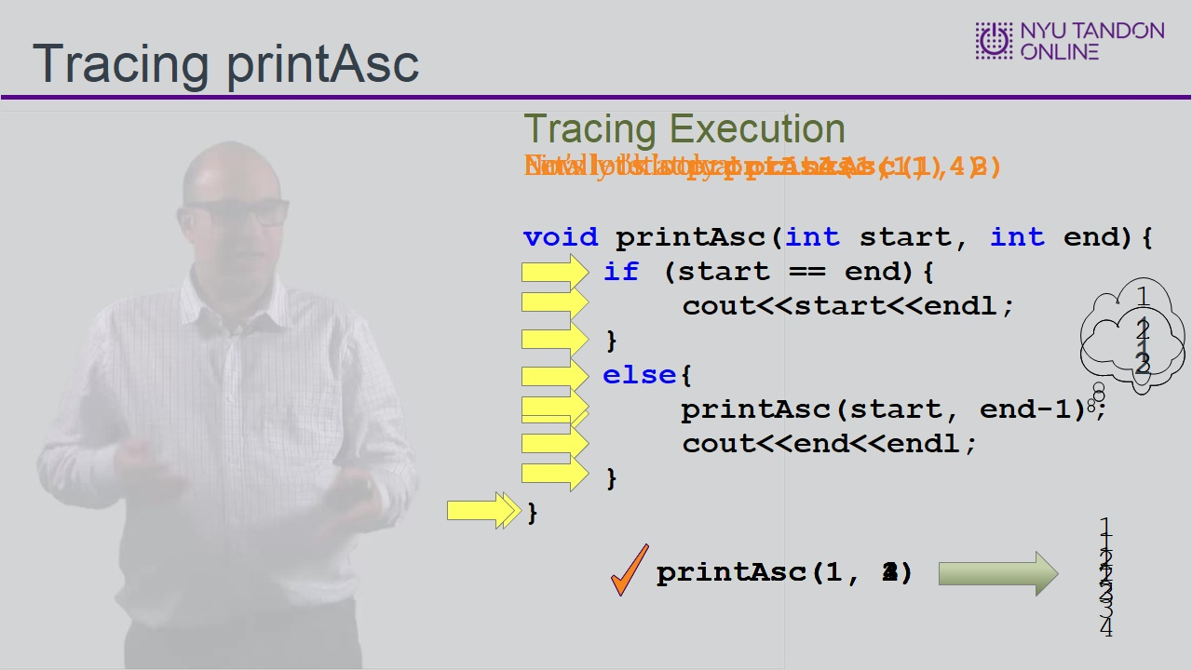
Notes:

1.5 Tracing printAsc Counted
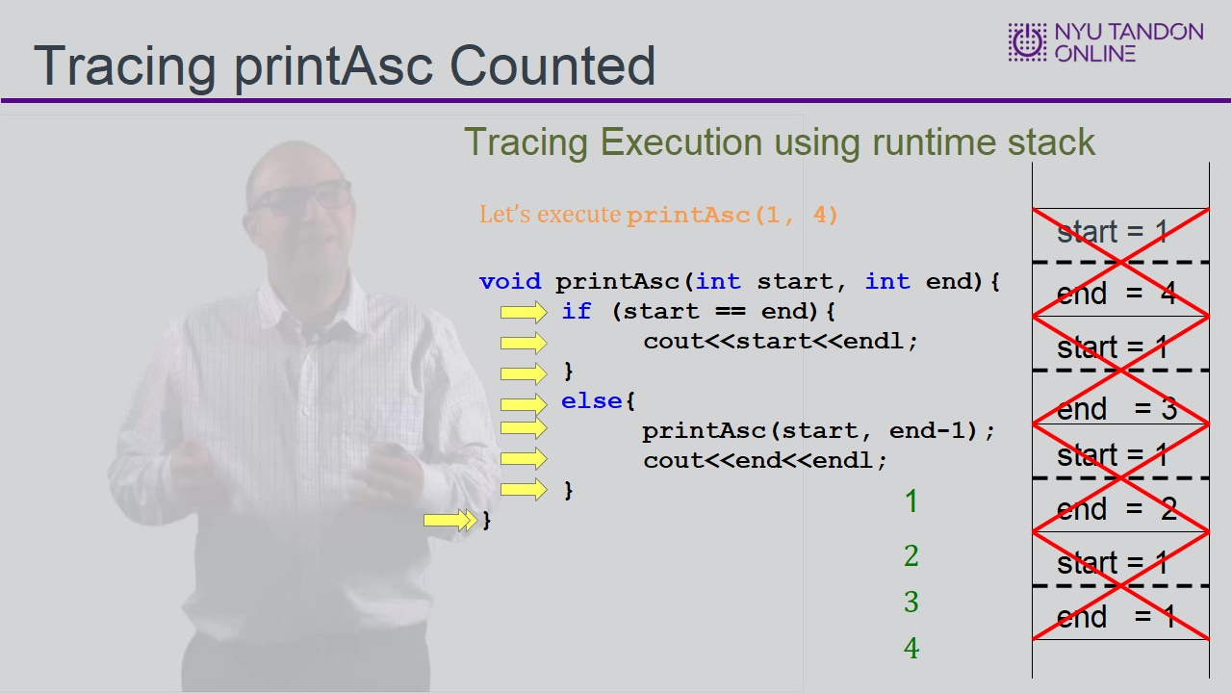

1.6 printAsc Alternative Implementations
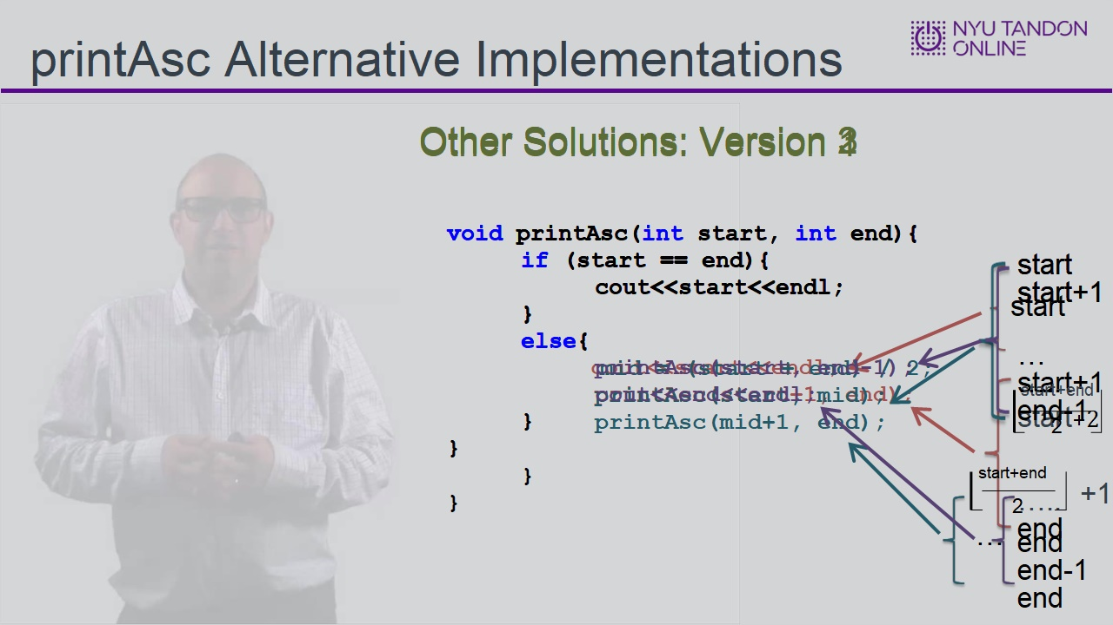
Notes:

1.7 Developing a Recursive Algorithm
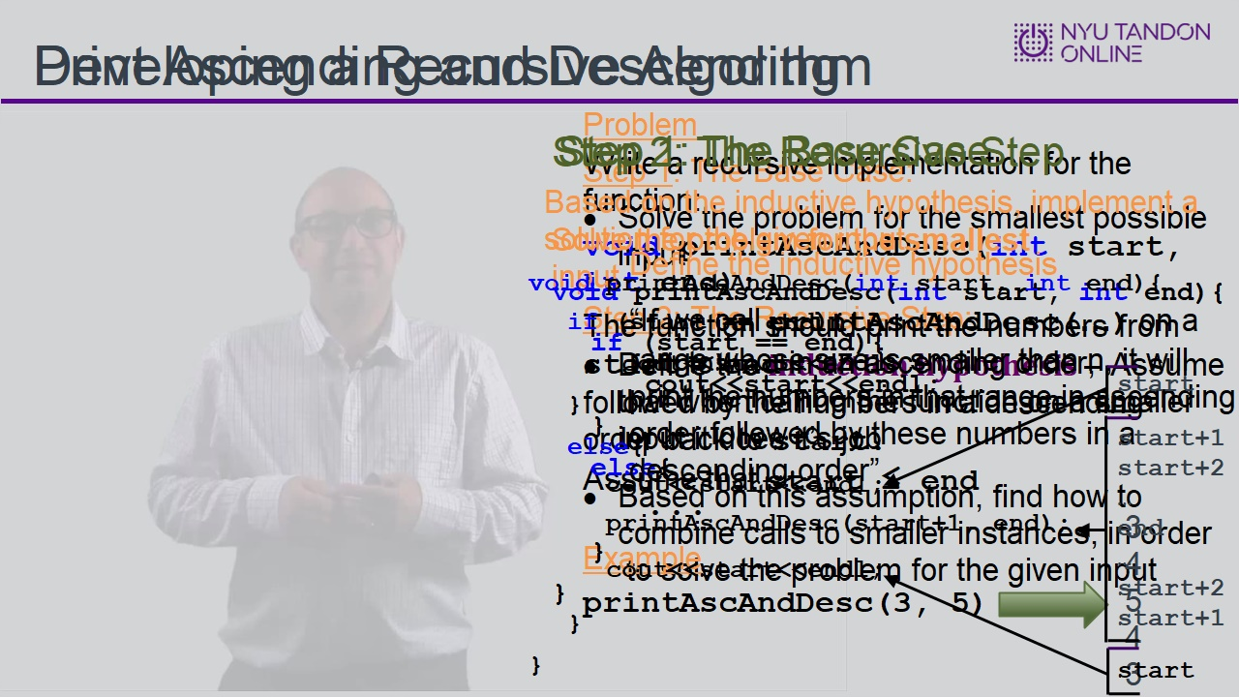
Notes:

1.8 End of Module
